# Holographic Remoting

## Unity project preparation

1. Build Settings: set build platform to UWP
2. import [MRTK fundamentals](https://github.com/microsoft/MixedRealityToolkit-Unity/releases/download/v2.4.0/Microsoft.MixedReality.Toolkit.Unity.Foundation.2.4.0.unitypackage)
3. Package Manager: add Windows Mixed Reality **v4.2.1** package
4. Package Manager: add MSBuild for Unity **v0.9.2** package(*may not need it, didn’t test without it*)
5. XRSettings : Enable Virtual Reality Support + add WMR SDK
6. XRSettings : enable WSA holographic Remoting
7. Download + import **HolographicRemoting** *prefab* and **HolographicRemoteConnect** *script* [MRTK.Tutorials.PCHolographicRemoting.unitypackage](https://github.com/onginnovations/MixedRealityLearning/releases/download/pc-holographic-remoting-v2.4.0.0/MRTK.Tutorials.PCHolographicRemoting.unitypackage)
8. XRSettings : 16-bit depth format + single pass instanced rendering mode
9. Capabilities:
   * InternetClient
   * InternetClientServer

### Screenshots

Package Manager

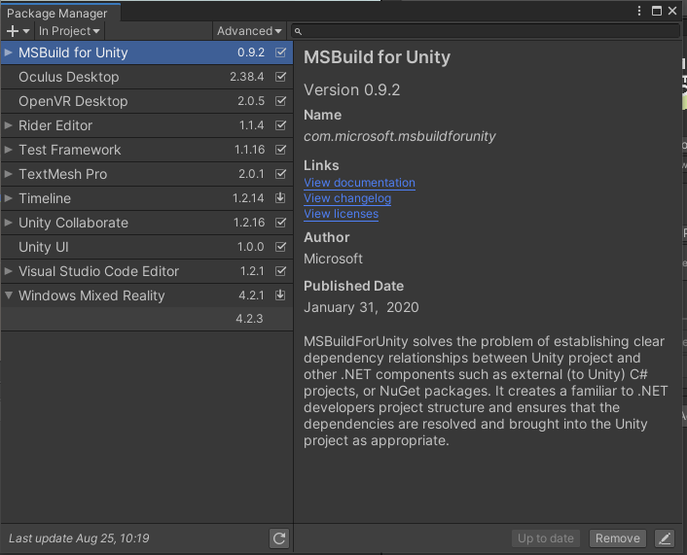

Build Settings

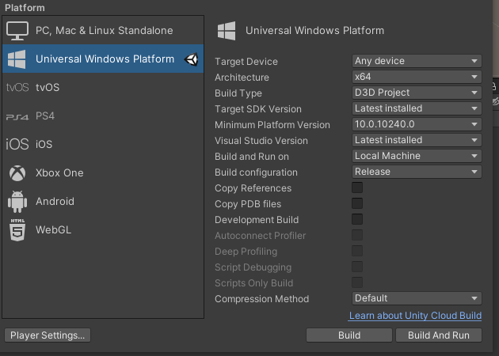

Capabilities

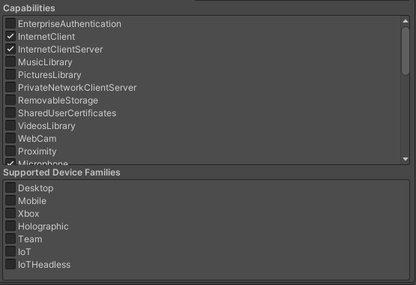

XRSettings

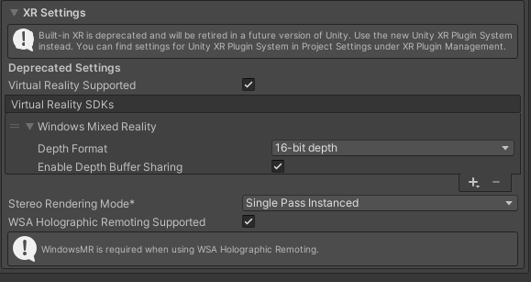

## Visual Studio settings

* Release + x64
* Local machine
* Start without debugging (CTRL+F5)

### Screenshots

